AirportWatch Conference. 28th/29th March 2009
The ‘Greening’ of Aviation: the final justification for airport expansion
Deepak Rughani, Biofuelwatch

Opening: A metaphor for our time:

A year ago just a few of us lacked faith in the financial system, yet today almost no one has faith in it. In the run up to economic collapse, instead of taking aversive action, we put our foot on the accelerator by deregulating the financial markets. The fallout means that instead of a recession we may well have triggered a depression.
Today just a few of us are concerned about the risks of ecological collapse; yet in a few years time all of us will be. In the run up to collapse instead of taking aversive action we’re putting our foot on the accelerator of environmental destruction by initiating false solutions. These include carbon trading in forests, agrofuels, large scale bioenergy from biomass, and now biochar. The fallout may well mean that instead of facing serious climate change, we will trigger collapse of many of our life-support systems, including the rainfall cycle, bringing famine to much of the globe.

Aviation plans to keep on expanding over the next 20 years, and using biofuels to cut its carbon emissions is the straw the industry is clutching at, in order to try and square the impossible contradiction of more planes but lower emissions.

2

Anti-aviation campaigns have been so successful that even opposition parties attempt to garner public support by questioning government plans over airport expansion!

3

However the justification just doesn’t add up. For one thing the economic recession and more-so a depression means that demand is and will continue to fall out the bottom. According to Brendan Sewall, the more likely predicted increase in passenger flights to 2030 could be completely met by more efficient use of existing airports! Futhermore, peak oil means a complete end to cheap flights.

4

Take a look at the four major concerns associated with aviation; climate change, noxious emissions, third party risk, and noise. Which of these can government and the aviation industry do almost nothing about? Yes all of them…except with the right PR and false accounting…greenhouse gas (GHG) emissions is something they can appear to deal with! Second question; which of these four gets most campaign attention? Yes climate change! They love it; we’re campaigning against the one thing they pretend they can do something about!

5

According to the International Air Transport Association (IATA) which serves as a lobbying group for the airlines, there are two ways in which they will give us reduced GHG emissions. One is more efficient aircraft (lighter, reduced drag, more efficient engines etc) and the second is use of biofuels.

6

And because biofuels are seen as a means of softening the peak oil crash, plus require no change in transportation infrastructure such as engines, plus promise big profits, the path for aviation biofuels closely matches the path already successfully trodden with biofuels for road transport.

In fact European legislation on biofuels – the Renewable Energy Directive – already allows aviation biofuels to count towards European transport targets on ‘renewable energy’ well before they are even commercially available. So from their point of view we can see this starting to fit together nicely.

7

Look also at the track record. Biofuels have already been used to sabotage campaigns for more efficient vehicles (engine efficiency targets reduced from 120 grams per kilometer to 130 g/km in the EU) and to validate plans for road expansion. The precedent is set, why wouldn’t they succeed with aviation?

8

There are also many players – from airline companies to biotech companies to venture capitalists - contributing vast sums to biokerosene research. Virgin is even contributing 10 years of profits worth $3 billion from all its travel businesses to research into ‘green’ energy – primarily biofuels.

So the aviation industry is clearly committed to biofuels whatever the cost.

9

But how do they manage to demonstrate favourable GHG balances?

Creative accounting!
First, direct land-use change can to some degree be side-stepped in the absence of a genuine verification scheme. There are some ‘sustainability standards’ which require auditing but they are so lax they don’t even include human rights violations including murder! Indirect land-use-change, i.e. arable land taken for fuel crops so food production is displaced into natural habitats cannot be quantified so it’s simply ignored! i.e. no emissions need be accounted for. Regarding both direct and indirect land-use change, peer reviewed research by Joseph Fargione shows that palm oil grown on drained tropical peat-land leaves a carbon debt of 840 years! This means it will take 840 years of continuous growing of palm oil before the initial emissions are cancelled out! And for other ecosystems and even set-aside land the upfront emissions leave a carbon debt of centuries or at best several decades.

10

The second piece of creative accounting involves underestimating the figures for the powerful GHG nitrous oxide, associated with industrial fertilisers. Paul Crutzen’s research shows nitrous oxide to be up to 70% more for oilseed rape and between 50% and 140% more for sugar beet than the estimates used in industry life-cycle assessments. Given that nitrous oxide is over 300 times as powerful a GHG than CO2, this is an important contribution to favourable GHG accounting.

Thirdly, useful co-products associated with the production of biofuels, such as cattle seed-cakes, are included on the basis that reduced cattle feed imports are required, whilst ignoring the massive increase in feed imports required because the land itself is now given over to fuel crops!

Finally industry is unable to accurately measure the vast loss in future sequestration capacity when a forest or other ecosystem is removed, just the very minor gains from growing the fuel crop, so this factor is also completely ignored.

As a result the biofuel industry claims life cycle emission reductions which are typically 35% or more below that of the fossil fuels they replace.

But there are other factors which industry and legislators have to routinely ignore.
11

One is the competition for land between food and fuel crop production. In the two years between 2007 and 2009 we have seen the numbers of people going hungry rise from 860 million to 1 billion globally, and according to a World Bank report leaked in 2008, 70% of this rise in hunger is due to biofuels.

12
Industry and legislators have also ignored very clear statements from experts describing the
impacts of the biofuels.
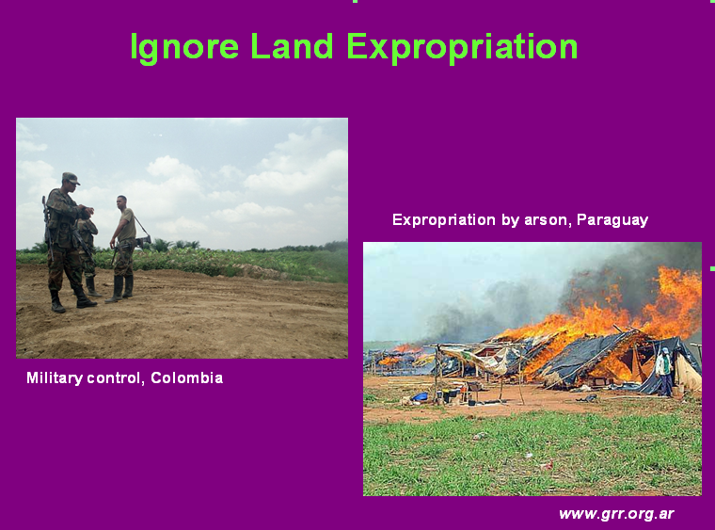13

They also have to ignore the many well-documented reports of evictions and land expropriation, as well as the human rights abuses and murders associated with biofuels. The social justice aspect of biofuels is therefore another key concern.

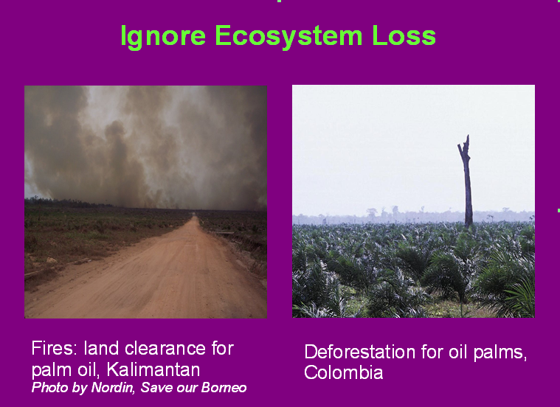14

Industry and legislators have also ignored the wider impacts of ecosystem destruction including emissions. These photographs show the changing landscape in two countries with high biodiversity, Kalimantan and Colombia. Scientists now say we’re already in the midst of a mass extinction event with losses of up to 50,000 species a year. With each species we lose, the web of life which holds ecosystems together is weakened. Put another way, species loss is an indirect climate feedback, unravelling the healthy function of ecosystems.

Similarly replacement of large areas of forest with cropland for example in the Amazon rainforest, dries out the remaining forest making it much more susceptible to fire. Regional drying is also a climate feedback threatening the once stable Amazon with collapse.

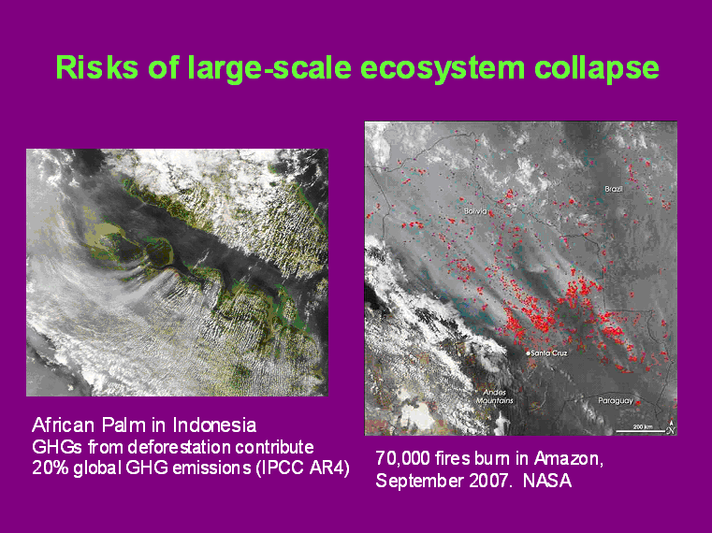15

In 2005 we had an El Nino year where drought devastated the Amazon. For each year since, instead of recovery the Amazon has experienced partial droughts. Scientists are concerned that this pattern of annual partial-drought conditions, combined with the increased incidence of fire – the right hand satellite photograph taken by NASA shows 70,000 fires blazing in just one day during the dry season of 2007 – maybe an early warning signal, one which we’re ignoring at our peril.

One likely prognosis is that as the forest becomes tinderbox dry, wild fires could burn at much higher temperatures. Instead of 200 to 400 degrees, they could burn at 1000 to 1200 degrees, producing infernos. Such ‘mega-fires’ would destroy not only the biomass above the ground, but also remove the rooting structures and seed material below the ground, turning large parts of the Amazon into a barren landscape. This will have dire consequences for us as the Amazon is a major player in the global rainfall cycle, upon which predictable crop production in the Americas and even as far away as South Africa depends.

It’s ironic that US biofuel legislation is resulting in accelerated deforestation in the Amazon, given that the US grain belt itself depends largely upon Amazonian rains! This really is the ‘Age of Stupid’!

16

This diagram gives a visual summary of the truer impact of biofuels as we’ve discussed. The first blue triangle shows up to 40% reduced emissions compared to equivalent fossil fuel use. Then add on the correct figure for nitrous oxide emissions. Then the up-front emissions from ecosystem loss; then the ongoing lost capacity to sequester atmospheric CO2. All the while we’re accelerating a number of climate feedbacks including biodiversity loss and regional drying. Unchecked this will result in collapse of key ecosystems. Global Climate Models give figures beyond 2030 for possible collapse of the Amazon resulting from background climate change. However, acceleration of this process by deforestation could make this a reality in less than ten years. At that point we would see our concerns for climate eclipsed by a desperate scramble to feed ourselves.

This is why we feel in discussing climate change it’s deeply simplistic and inaccurate to base our analysis simply on GHG emissions. Ecosystem destruction is integral and should be part of any discussion and campaign on reducing GHG emissions.

17

So linking ecosystem destruction back to the demand for biofuels…
Something does indeed seem to be happening in the airline industry: A flurry of test flights were made during the last year using a variety of different biofuel feed-stocks, each to significant media attention.

In February 08 Virgin Atlantic tested biokerosene derived from a mixture of Brazilian babassu nuts and coconuts, between Heathrow and Amsterdam. It’s estimated that 150,000 coconuts were required to meet just 5% of the fuel requirement. According to an article in Red Pepper at the time, 45 million coconuts would be required for a one-way trip between London and New York. Note the Guardian and Red Pepper headlines at the time!

The volumes of course don’t make commercial sense; Virgin see the coconut stunt as a stepping stone to algal biofuels.

18

Air New Zealand, Japan Airlines and Continental experimented with inedible Jatropha oil which is also known to be poisonous to livestock. Part of the reason is that it creates the illusion of not competing in the food market, even though it competes with food for land use. Worse still, as an inedible oil, it cannot be substituted back into the food market in a crisis.

19

Air New Zealand, Boeing, Rolls Royce and UOP (a Honeywell subsidiary) have undergone a joint experiment with 50% blend of Jatropha in one of two engines.

20

At the end of January, Japan Airlines conducted the world’s first biofuel test fight with another inedible oil, Camelina as well as with smaller quantities of Jatropha and algal biofuels.

21

Jan 09 Continental Airlines did a test flight with a plane running on biofuel made from algae and Jatropha. JetBlue Airways plan a biokerosene test flight before the Spring of 2010.

JetBlue are also preparing for Airbus test flight in 2010 adding waste forest residue for the first time.

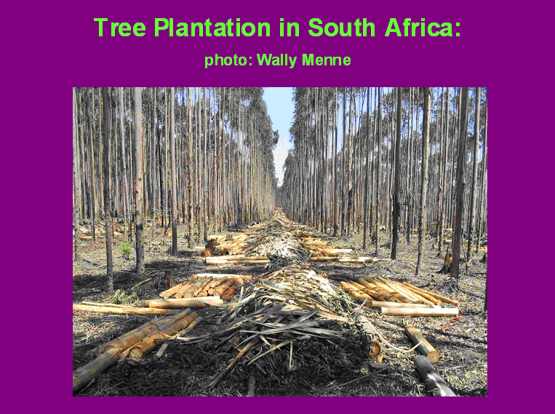22

However research into biofuel substitutes for kerosene is by no means the exclusive preserve of airline companies. The US government have tasked the US military with sourcing 50% of its fuel for the lower 48 US states from domestic ‘non oil sources’ by 2016. Inevitably this means biofuels but there are also other kerosene substitutes.

23

Aviation fuel can be made from coal and natural gas, using a technique developed originally during the Second World War called Fischer-Tropsch gasification, through which liquid hydrocarbon fuels known as ‘synfuel’ can be made which can be further-refined into aviation fuel. The same process can also be used to produce liquid aviation fuels from biomass.

So far however, biomass synfuel uses so much energy that it makes no economic sense to use it. One way of making it profitable would be to use an ‘intermediate’ process first. By burning biomass in the absence of oxygen, a process known as pyrolysis, syngas and bio-oil are produced which can then be put through the Fischer-Tropsch gasification and turned into aviation fuel.

However pyrolysis also produces another by-product - charcoal – which the industry are relabeling ‘biochar’ to give it a green feel. Some of you will have heard of biochar; it’s being touted as a climate change solution when added to soils because it contains carbon which was previously in the atmosphere. However even this is gravely problematic. For one thing industrial biochar appears to oxidise in soil, so over time much of the carbon could be released. For another, it’s yet a further excuse to convert millions more hectares of natural habitat into biologically inert tree plantations. And without such plantations there can be no large-volume syngas for bio-kerosene either.

And how they’ll ensure its profitable can be summarised in three familiar ways: carbon credits, targets and subsidies. Carbon credits for monoculture plantations which they falsely argue are carbon sinks! Also carbon credits for biochar, which they falsely argue is a permanent carbon store and finally targets and big subsidies for the biofuel! Ironically each of these components can be described as a “false solution”, each further destabilising climate and other life support systems.

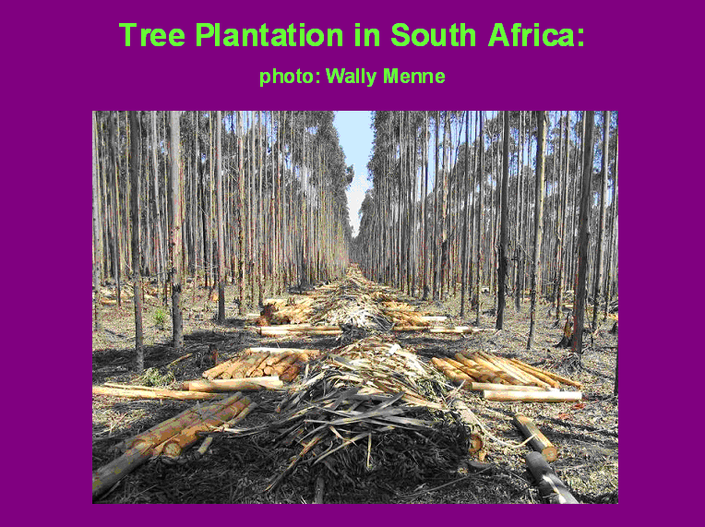24

Strictly speaking pyrolysed biomass is a form of Second Generation biofuels because it involves the conversion of solid biomass to liquid fuel.

Another second generation biofuel involves the biochemical breakdown of solid biomass to liquids through microbial activity. In nature it takes months or years to break down woody plant tissue. Genetic engineers plan to achieve this in just a day or even a few hours using genetically modified (GM) or genetically engineered (GE) microbes. This is seen as the holy grail of second generation biofuels because it may well return more energy than invested in the process. But as you can imagine, it’s also very scary stuff. Genetically engineered anything has no fit in the natural environment. Imagine for example if such GE microbes were to escape. As our remaining natural forests turn to pulp there would be no way of closing this particular Pandora’s box.

There are reports that a GM microbe capable of rapidly digesting any type of wheat was nearly introduced into fields. Fortunately the risks were discovered in time – but what if such dangers are missed in the future? Once created GM and GE microbes would be used in potentially hundreds of refineries across the globe, making their long-term containment very questionable.

25

There is the expectation that in future, biofuels will come from suitable algae grown in tanks (known as bioreactors) or in open water. Algal biofuels are termed Third Generation. They are available now but cost more in energy to produce then is returned from the fuel. The holy grail of algal biofuels again involves genetic modification or genetic engineering. The conundrum is this: Algae either use energy to grow in size or to produce more oil, not both. Genetic engineers are looking however to create algae which can do both. Contrary to the impression given by the industry, this particular magic trick may still be over a decade away and holds the same risk of decimating ecosystems - in this case freshwater and marine - associated with 2nd generation GM or GE ‘solutions’.

Bringing all this together now:

The technology already exists to create aviation biofuels from food crops, from non-food crops and from the by-products of biomass pyrolysis.

The precedent of calling these destructive fuels ‘low emission’ is also already set in EU legislation for road transport fuels and backed with targets and financial incentives.

GM and GE variants for Second and Third generation biofuels would offer new and possibly cheaper options for bulk production but are by no means necessary to promote a ‘greening’ of aviation.

Vast new tree monoculture plantations will however be required whichever second generation option is used. So if governments are successful with ‘greening’ aviation with biofuels, they’ll also be successful in stripping away the last vestiges of natural habitat, with disastrous consequences.

26

Geoff Hoon, the UK’s Secretary of State for Transport has already set the biofuel challenge to the aviation industry, to make aviation biofuels a reality within 5 years.

27

…and Lord Turner, Chair of the UK’s Climate Change Committee has already made the link between aviation biofuels, airport expansion and meeting the UK climate obligation targets…the ultimate conjuring trick!

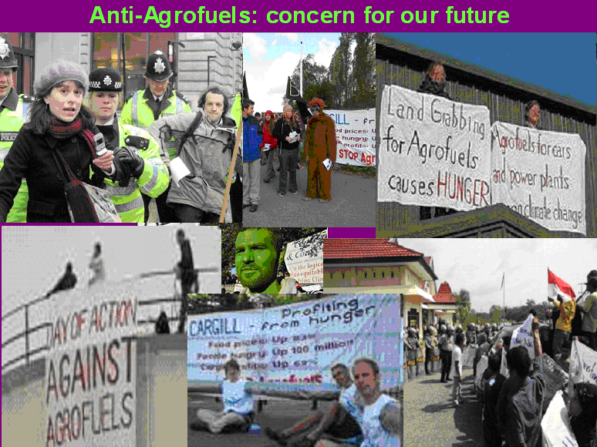28

